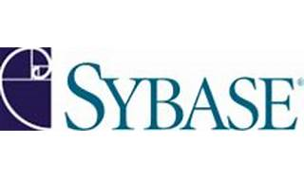



Explore

**Sybase** was an enterprise software and services company specializing in relational databases. It produced software to manage and analyze business information and processes across mobile platforms. [In 2010, **SAP acquired Sybase** to enhance its data management portfolio and realize its in-memory computing vision1](https://www.sap.com/products/acquired-brands/what-is-sybase.html)[2](https://en.wikipedia.org/wiki/Sybase).

Here are **five free reference links** where you can learn more about Sybase:

1. [**SAP’s official page on Sybase**](https://www.sap.com/products/acquired-brands/what-is-sybase.html): Provides an overview of Sybase and its integration with SAP solutions.
2. [**Wikipedia’s article on Sybase**](https://en.wikipedia.org/wiki/Sybase): Offers detailed information about Sybase’s history, products, and acquisition by SAP.
3. [**StackShare’s Sybase profile**](https://stackshare.io/sybase): Describes Sybase as a high-performance SQL database server used for transaction-based applications.
4. [**PCMag’s definition of Sybase**](https://www.pcmag.com/encyclopedia/term/sybase): Briefly explains Sybase’s focus on enterprise infrastructure and integration.
5. **Sybase on MEL Magazine**: Okay, this last one isn’t directly about Sybase, but it’s a fun read about banana lengths! 🍌

Feel free to explore these resources to deepen your understanding of Sybase! 😊